Space

Definition
# Source: AI Source: Provided by: [Data Path: Persons Table -> ID Column: 1, Name_En Column: Motasem Essam] -> From: [ChatGPT] on [7/20/2026]
In geometry, Space is the three-dimensional extent in which points, lines, planes, surfaces, and solid geometric objects are located.
It is commonly represented by three-dimensional Euclidean space, denoted by:
$$\boxed{R^{3}}$$
A point in space can be specified using three coordinates:
$$\boxed{P\left(x , y , z\right)}$$
where:
- $x$represents position along the x-axis.
- $y$represents position along the y-axis.
- $z$represents position along the z-axis.
Unlike Plane Geometry, which studies two-dimensional geometry, space provides the setting for three-dimensional geometry.
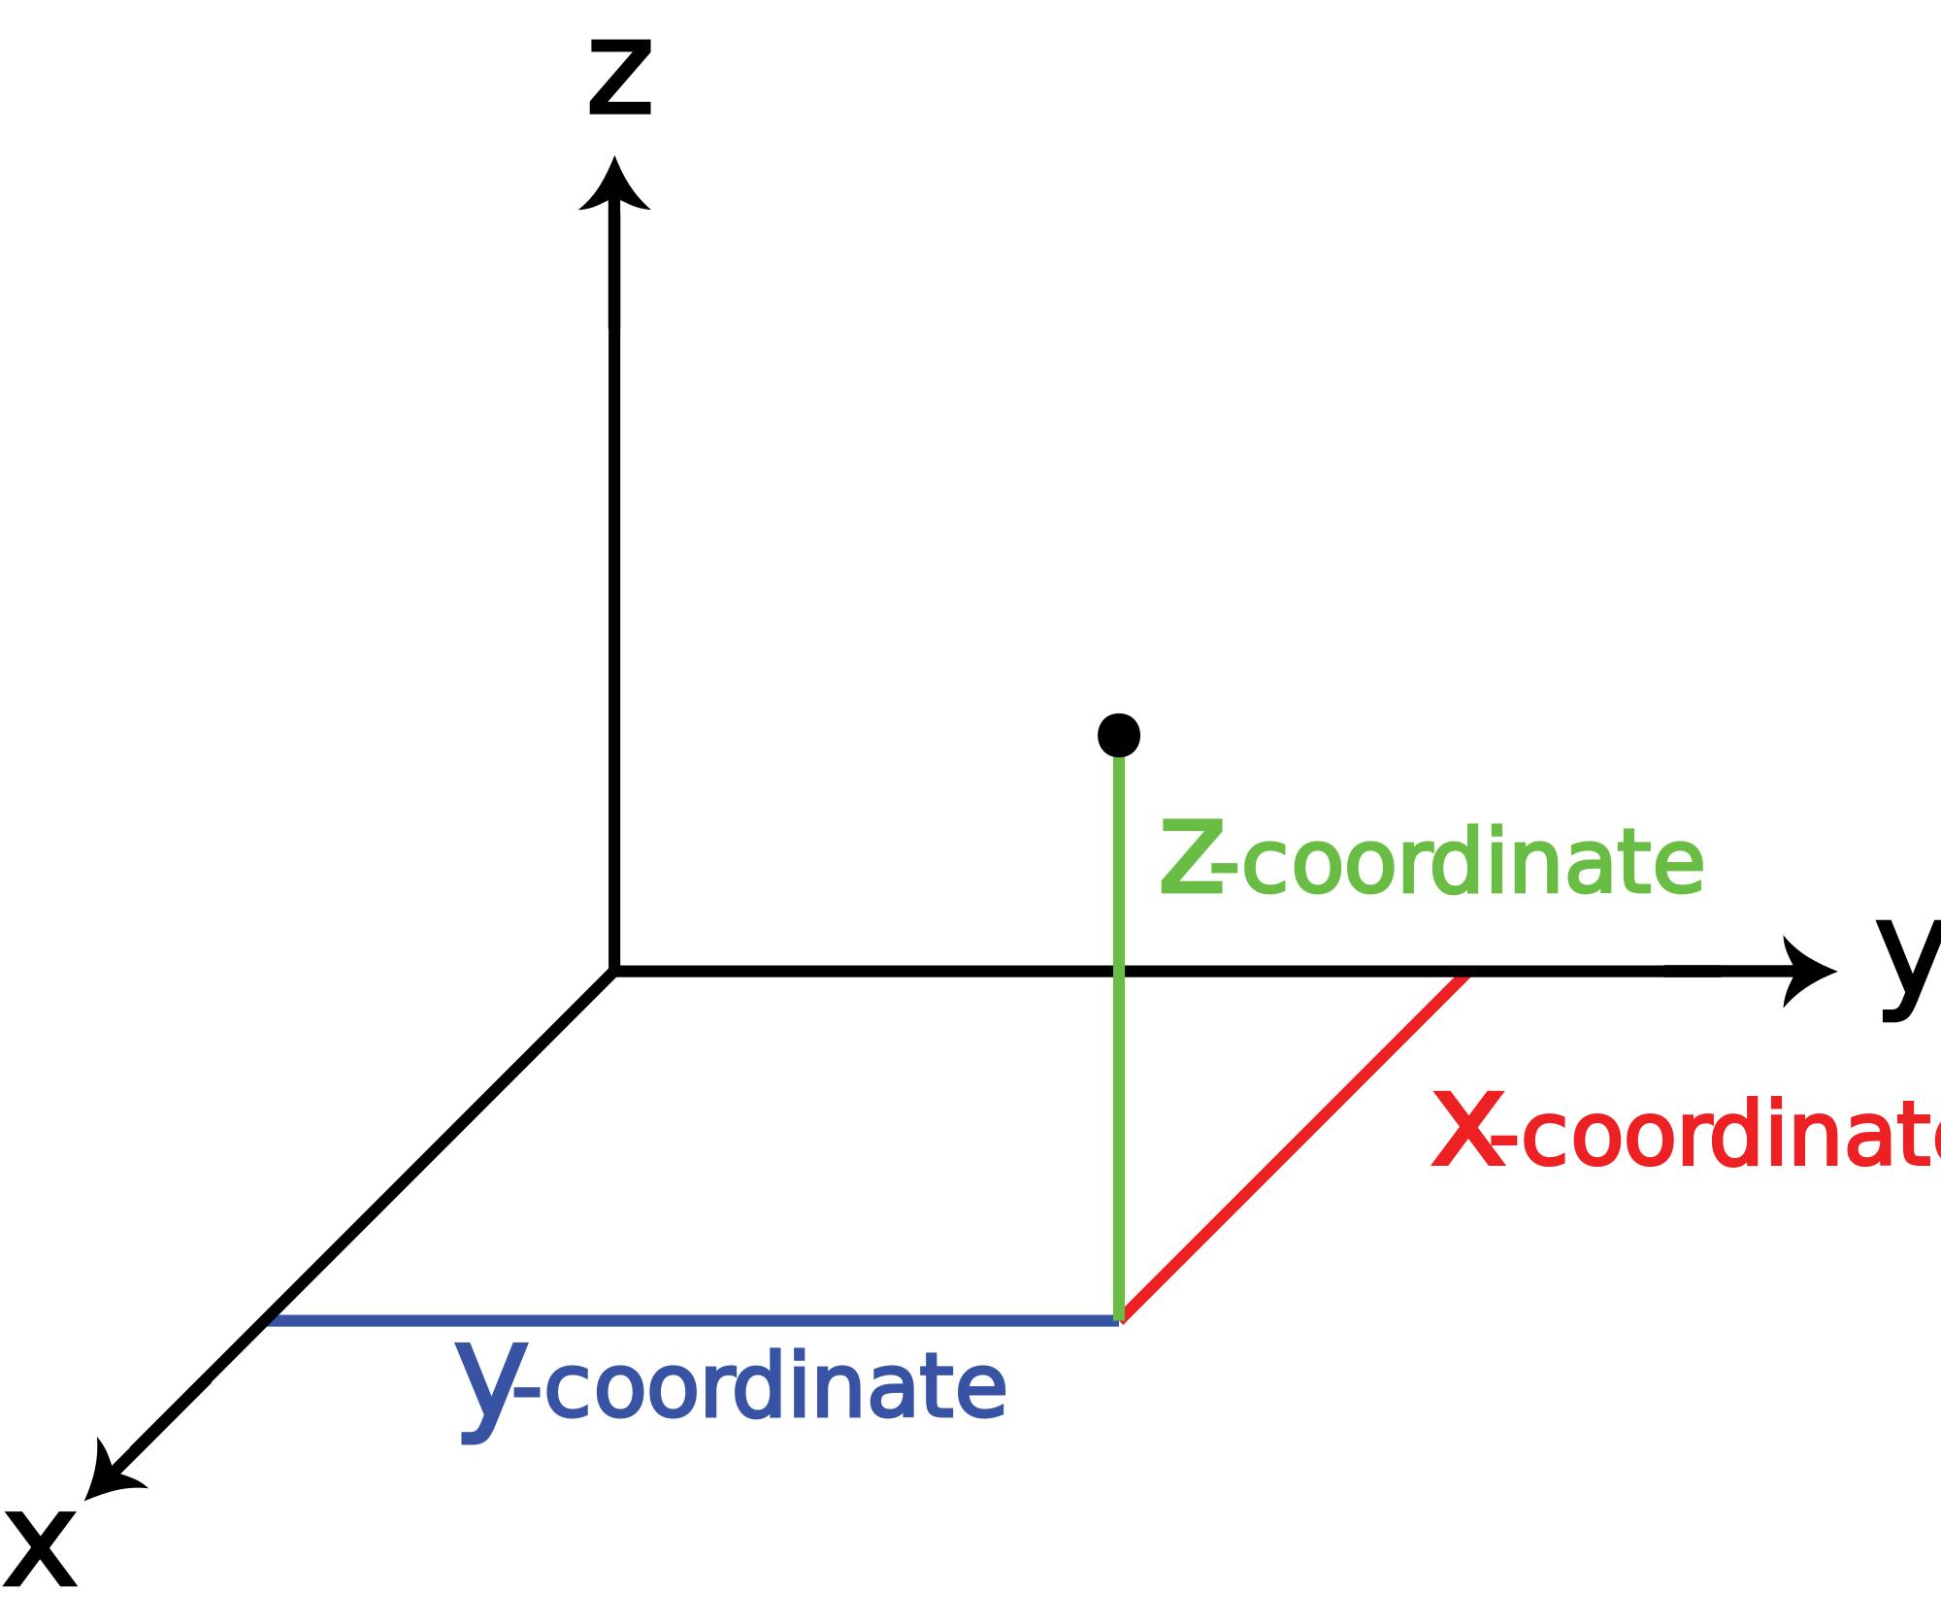
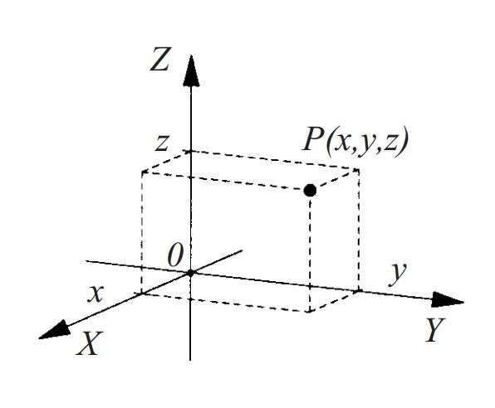
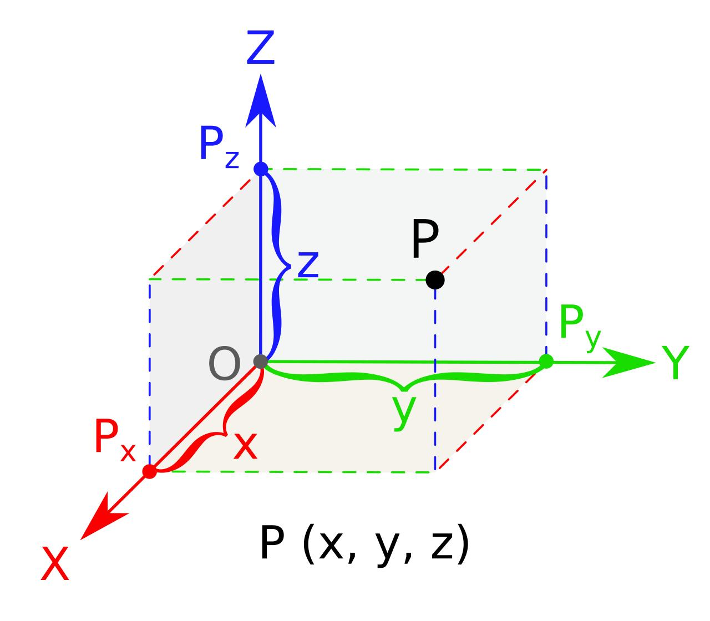
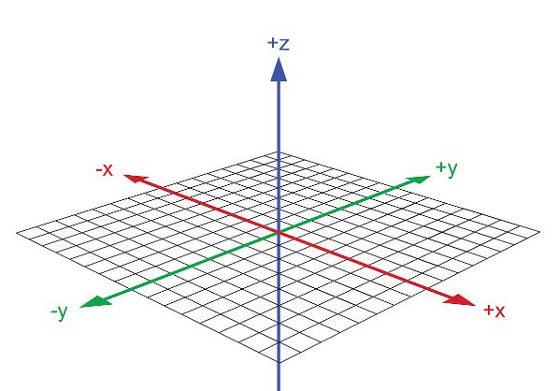
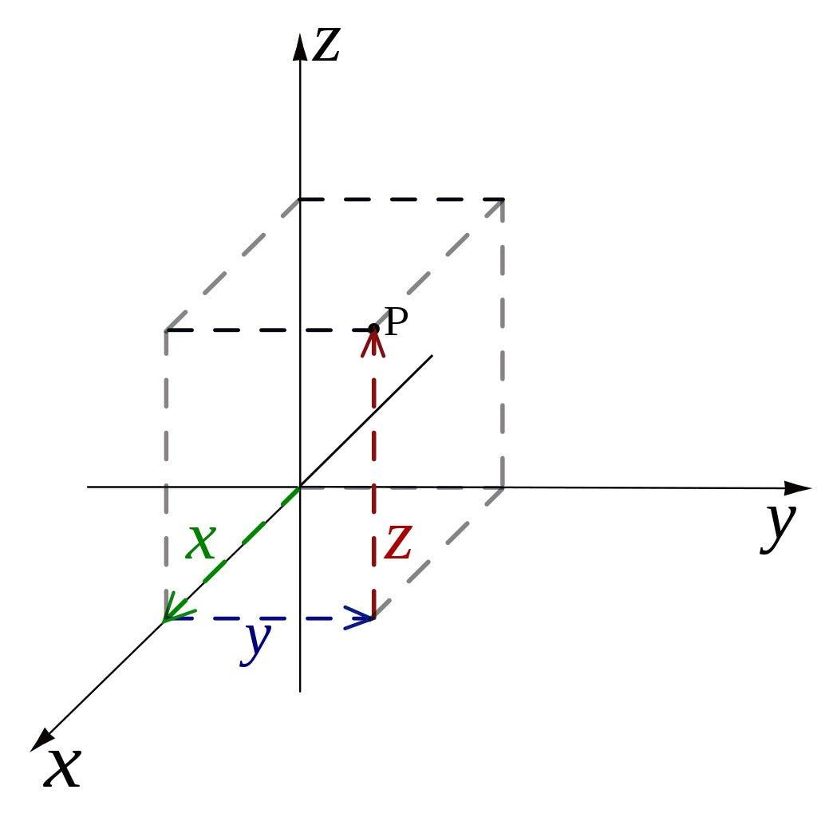
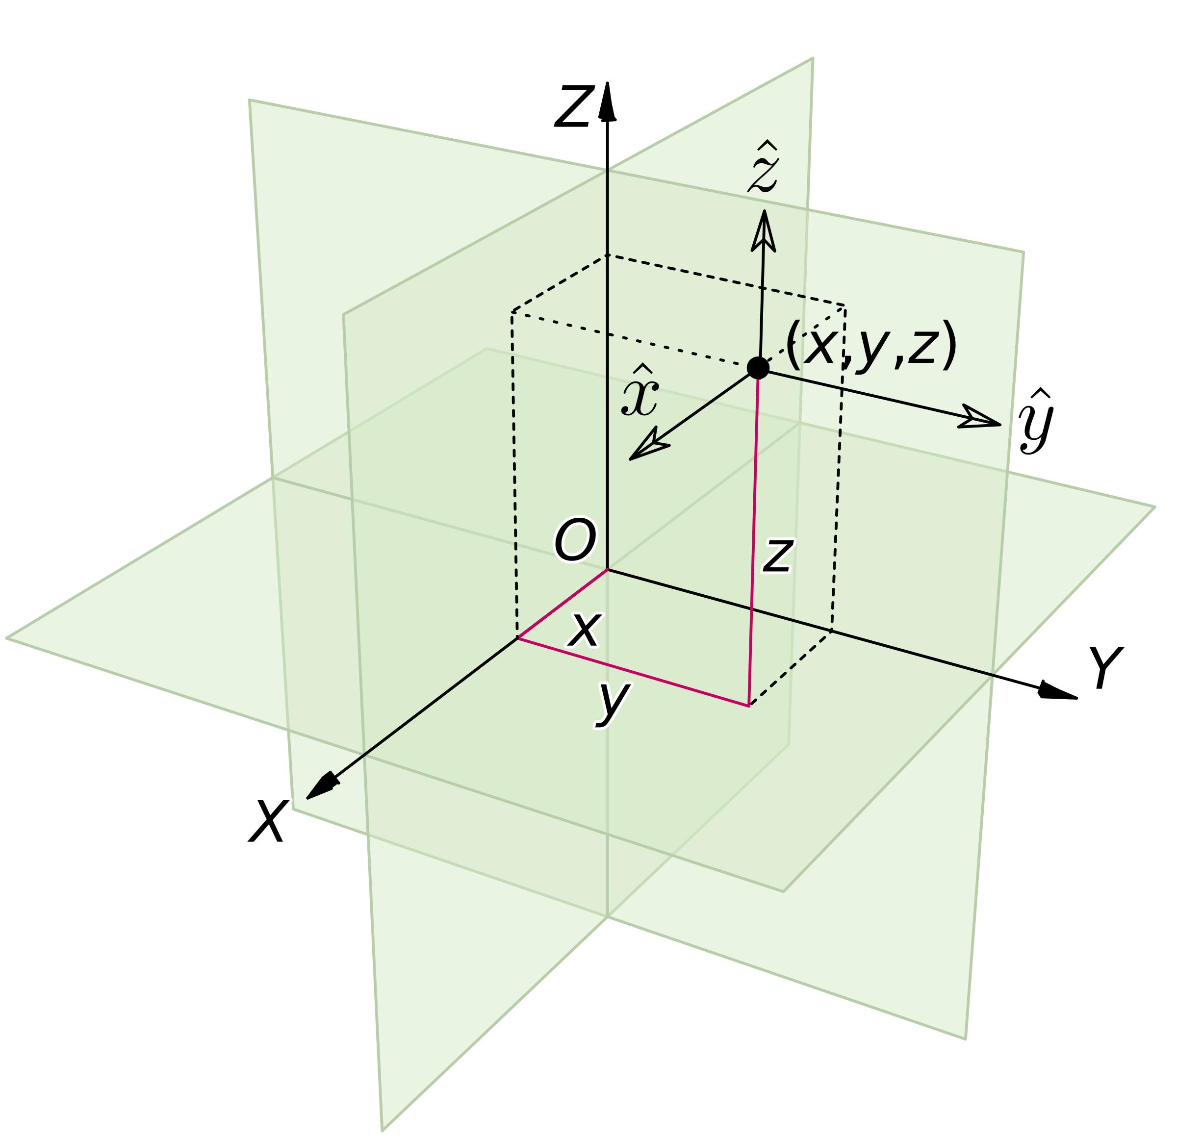

Purpose
# Source: AI Source: Provided by: [Data Path: Persons Table -> ID Column: 1, Name_En Column: Motasem Essam] -> From: [ChatGPT] on [7/20/2026]
Space provides the geometric framework for:
- Describing three-dimensional positions.
- Studying points, lines, and planes in three dimensions.
- Studying surfaces and solids.
- Measuring distances, angles, areas, and volumes.
- Representing three-dimensional objects mathematically.
- Studying spatial relationships and transformations.
- Modeling physical objects and environments.

Fundamental Elements of Space
# Source: AI Source: Provided by: [Data Path: Persons Table -> ID Column: 1, Name_En Column: Motasem Essam] -> From: [ChatGPT] on [7/20/2026]
The fundamental geometric elements within space include:

1. Point
# Source: AI Source: Provided by: [Data Path: Persons Table -> ID Column: 1, Name_En Column: Motasem Essam] -> From: [ChatGPT] on [7/20/2026]
A point represents a specific location in space.
$$P\left(x , y , z\right)$$
A point has position but no length, width, or thickness.

2. Line
# Source: AI Source: Provided by: [Data Path: Persons Table -> ID Column: 1, Name_En Column: Motasem Essam] -> From: [ChatGPT] on [7/20/2026]
A line extends infinitely in both directions.
A line in space can be represented parametrically as:
$$\boxed{r=a+td}$$
where:
- $a$is a point on the line.
- $d$is a direction vector.
- $t∈R$.

3. Plane
# Source: AI Source: Provided by: [Data Path: Persons Table -> ID Column: 1, Name_En Column: Motasem Essam] -> From: [ChatGPT] on [7/20/2026]
A plane is a flat two-dimensional surface extending infinitely in two independent directions.
Its general equation is:
$$\boxed{ax+by+cz=d}$$
where $a,b,c$are not all zero.

4. Surface
# Source: AI Source: Provided by: [Data Path: Persons Table -> ID Column: 1, Name_En Column: Motasem Essam] -> From: [ChatGPT] on [7/20/2026]
A surface is a two-dimensional geometric object embedded in three-dimensional space.
Examples include:
- Plane surfaces
- Spherical surfaces
- Cylindrical surfaces
- Conical surfaces
- Toroidal surfaces

5. Solid
# Source: AI Source: Provided by: [Data Path: Persons Table -> ID Column: 1, Name_En Column: Motasem Essam] -> From: [ChatGPT] on [7/20/2026]
A solid occupies a three-dimensional region of space.
Examples include:
- Cube
- Sphere
- Cylinder
- Cone
- Prism
- Pyramid
- Torus

Dimensions of Space
# Source: AI Source: Provided by: [Data Path: Persons Table -> ID Column: 1, Name_En Column: Motasem Essam] -> From: [ChatGPT] on [7/20/2026]
Ordinary Euclidean space has three spatial dimensions:
$$\boxed{3D}$$
These dimensions are conventionally represented by:
$$x, y, z$$
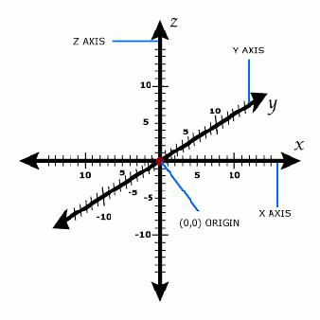
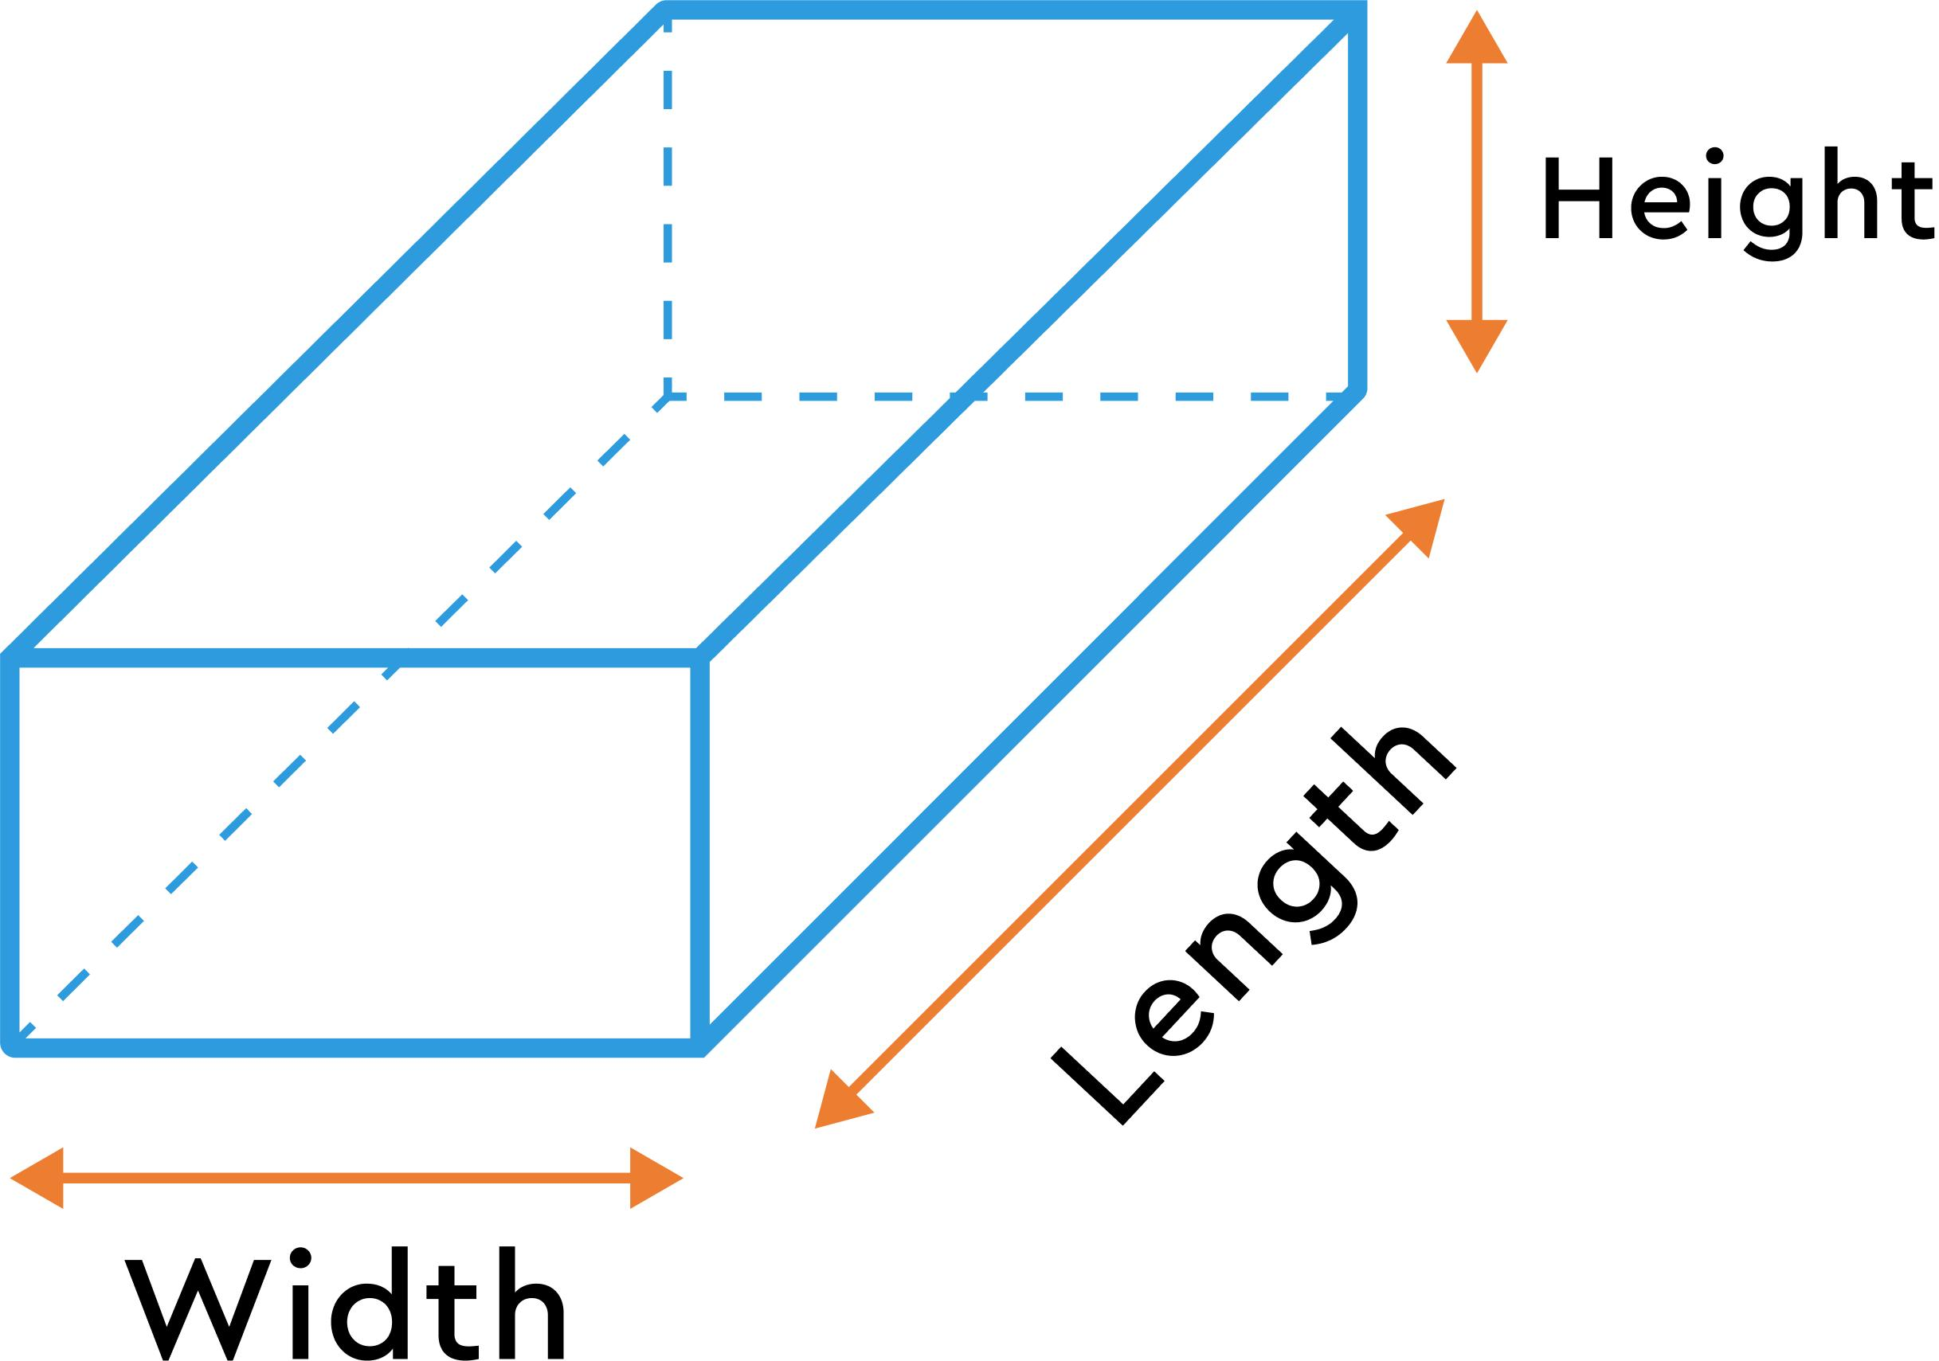
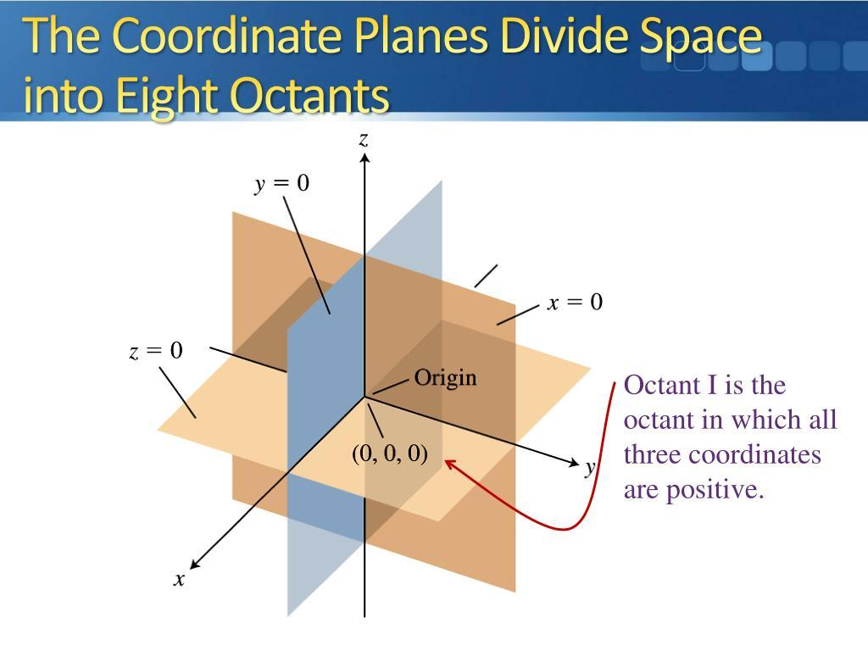
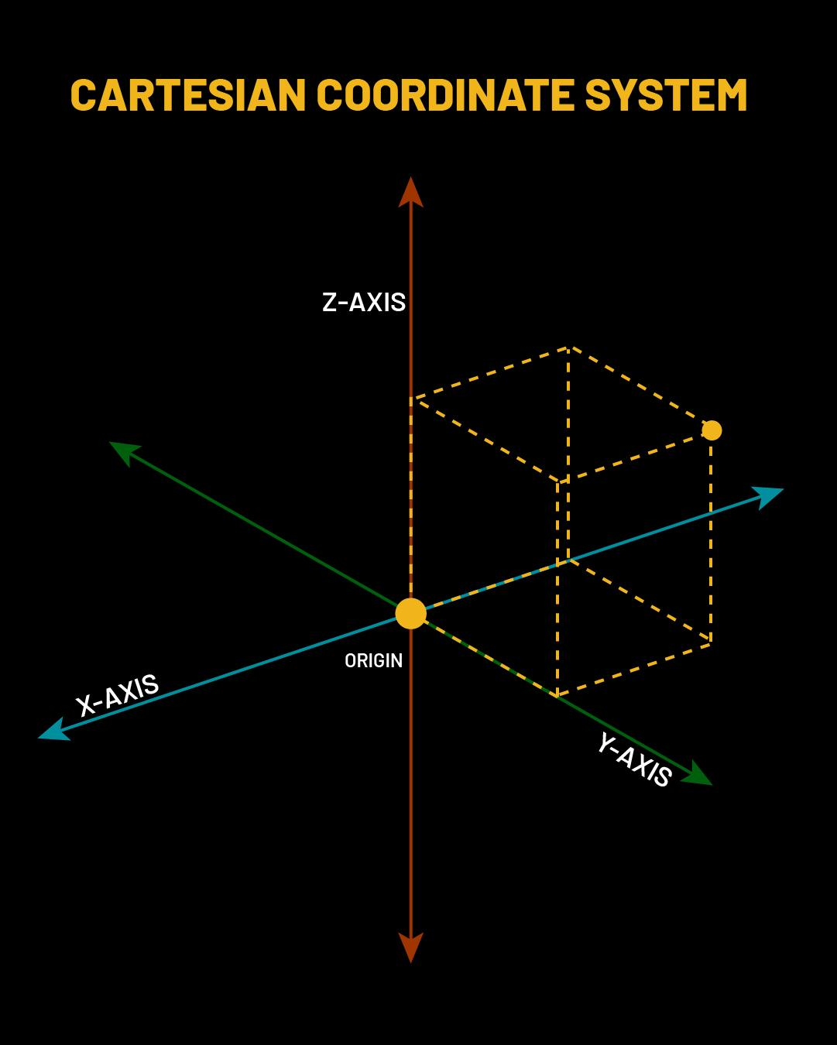
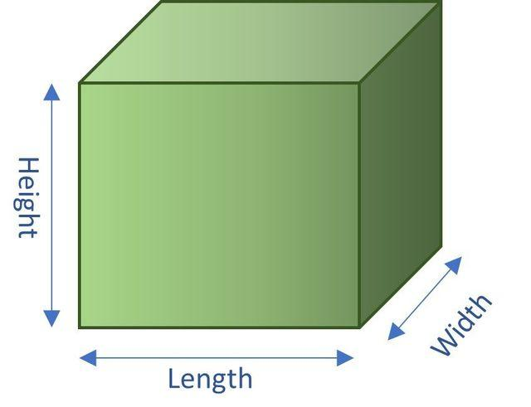
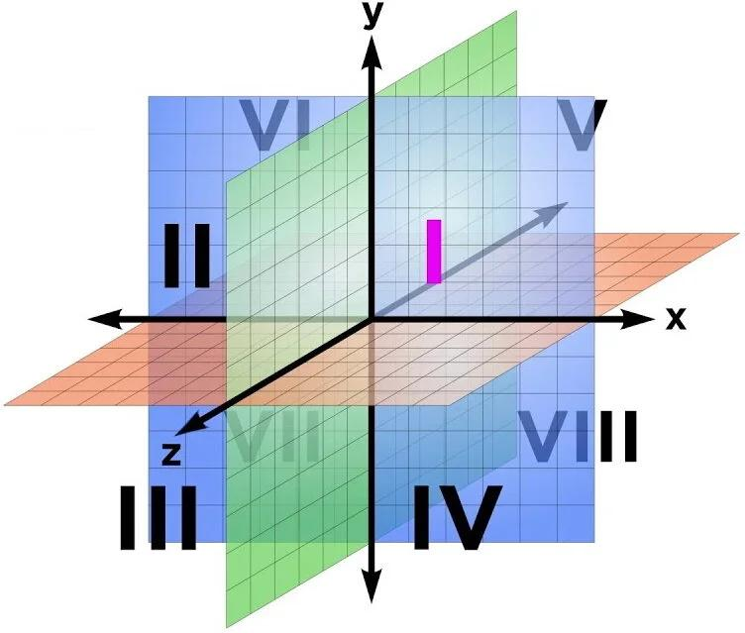
They can be interpreted geometrically as three mutually perpendicular directions.
For example:
- $x$: left–right
- $y$: forward–backward
- $z$: up–down
These interpretations depend on the chosen coordinate system.

Coordinate Space
# Source: AI Source: Provided by: [Data Path: Persons Table -> ID Column: 1, Name_En Column: Motasem Essam] -> From: [ChatGPT] on [7/20/2026]
The standard mathematical model of three-dimensional Euclidean space is:
$$\boxed{R^{3}}$$
A point is represented as an ordered triple:
$$\boxed{P=\left(x , y , z\right)}$$
For example:
$$P=\left(3 , 4 , 5\right)$$
identifies one specific point in space.
The origin is:
$$\boxed{O=\left(0 , 0 , 0\right)}$$

Coordinate Axes
# Source: AI Source: Provided by: [Data Path: Persons Table -> ID Column: 1, Name_En Column: Motasem Essam] -> From: [ChatGPT] on [7/20/2026]
The three coordinate axes meet at the origin.
x-axis
$$y=0, z=0$$
y-axis
$$x=0, z=0$$
z-axis
$$x=0, y=0$$
Together they establish the three-dimensional Cartesian coordinate system.

Coordinate Planes
# Source: AI Source: Provided by: [Data Path: Persons Table -> ID Column: 1, Name_En Column: Motasem Essam] -> From: [ChatGPT] on [7/20/2026]
The three principal coordinate planes are:
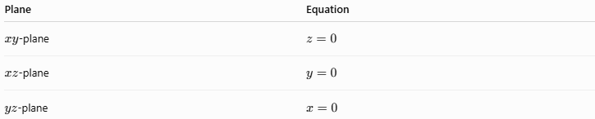
Plane | Equation
$xy$-plane | $$z=0$$
$xz$-plane | $$y=0$$
$yz$-plane | $$x=0$$
These planes divide three-dimensional space into eight octants.

Distance Between Two Points in Space
# Source: AI Source: Provided by: [Data Path: Persons Table -> ID Column: 1, Name_En Column: Motasem Essam] -> From: [ChatGPT] on [7/20/2026]
For:
$$P_{1}=\left(x_{1} , y_{1} , z_{1}\right)$$
and:
$$P_{2}=\left(x_{2} , y_{2} , z_{2}\right)$$
the distance between them is:
$$\boxed{d=\sqrt{{\left(x_{2}-x_{1}\right)}^{2}+{\left(y_{2}-y_{1}\right)}^{2}+{\left(z_{2}-z_{1}\right)}^{2}}}$$
Example
Let:
$$A=\left(1 , 2 , 3\right)$$
and:
$$B=\left(4 , 6 , 3\right)$$
Then:
$$d=\sqrt{{\left(4-1\right)}^{2}+{\left(6-2\right)}^{2}+{\left(3-3\right)}^{2}} \\ d=\sqrt{9+16} \\ \boxed{d=5}$$

Geometry Within Space
# Source: AI Source: Provided by: [Data Path: Persons Table -> ID Column: 1, Name_En Column: Motasem Essam] -> From: [ChatGPT] on [7/20/2026]
Space contains many different geometric objects and relationships.
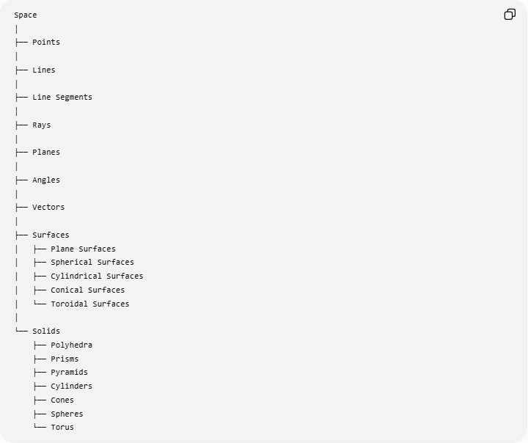
Space
│
├── Points
│
├── Lines
│
├── Line Segments
│
├── Rays
│
├── Planes
│
├── Angles
│
├── Vectors
│
├── Surfaces
│ ├── Plane Surfaces
│ ├── Spherical Surfaces
│ ├── Cylindrical Surfaces
│ ├── Conical Surfaces
│ └── Toroidal Surfaces
│
└── Solids
├── Polyhedra
├── Prisms
├── Pyramids
├── Cylinders
├── Cones
├── Spheres
└── Torus

Spatial Relationships
# Source: AI Source: Provided by: [Data Path: Persons Table -> ID Column: 1, Name_En Column: Motasem Essam] -> From: [ChatGPT] on [7/20/2026]
Objects in space can have relationships such as:
- Coincidence
- Intersection
- Parallelism
- Perpendicularity
- Skewness
- Containment
- Tangency
- Distance
- Angular relationships

Parallel Lines
# Source: AI Source: Provided by: [Data Path: Persons Table -> ID Column: 1, Name_En Column: Motasem Essam] -> From: [ChatGPT] on [7/20/2026]
Two lines in space are parallel if they have parallel direction vectors and do not intersect.
Perpendicular Lines
Two intersecting lines are perpendicular when their angle is:
$$\boxed{{90}^{∘}}$$
Skew Lines
Skew lines are two lines in three-dimensional space that:
- do not intersect,
- are not parallel,
- and do not lie in the same plane.
This is a relationship that cannot occur between two lines in ordinary two-dimensional plane geometry.

Space and Plane Geometry
# Source: AI Source: Provided by: [Data Path: Persons Table -> ID Column: 1, Name_En Column: Motasem Essam] -> From: [ChatGPT] on [7/20/2026]
There is an important dimensional relationship:
$$\boxed{\text{Plane}⊂\text{Space}}$$
A plane is a two-dimensional geometric object contained within three-dimensional space.
For example, the $xy$-plane is a plane inside:
$$R^{3}$$
while ordinary plane geometry can be modeled using:
$$R^{2}$$
Therefore:
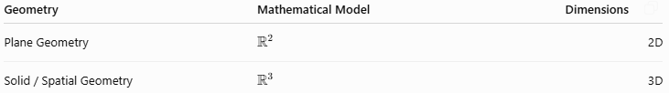
Geometry | Mathematical Model | Dimensions
Plane Geometry | $$R^{2}$$ | 2D
Solid / Spatial Geometry | $$R^{3}$$ | 3D

Space and Solid Geometry
# Source: AI Source: Provided by: [Data Path: Persons Table -> ID Column: 1, Name_En Column: Motasem Essam] -> From: [ChatGPT] on [7/20/2026] # Source: AI Source: Provided by: [Data Path: Persons Table -> ID Column: 1, Name_En Column: Motasem Essam] -> From: [ChatGPT] on [7/20/2026]
Solid Geometry studies three-dimensional geometric objects and their properties.
It includes:
- Polyhedra
- Prisms
- Pyramids
- Cylinders
- Cones
- Spheres
- Torus
- Three-dimensional coordinates
- Volumes
- Surface areas
- Spatial angles
- Spatial relationships
Thus:
$$\boxed{\text{Space is the setting; Solid Geometry studies objects within it.}}$$

Mathematical Representation of Space
# Source: AI Source: Provided by: [Data Path: Persons Table -> ID Column: 1, Name_En Column: Motasem Essam] -> From: [ChatGPT] on [7/20/2026]
The standard Euclidean space is:
$$\boxed{R^{3}}$$
which can be written as:
$$\boxed{R^{3}=\left\{\left(x , y , z\right) , ∣ , xyz∈R\right\}}$$
Every ordered triple of real numbers corresponds to one point in three-dimensional Cartesian space.

Transformations in Space
# Source: AI Source: Provided by: [Data Path: Persons Table -> ID Column: 1, Name_En Column: Motasem Essam] -> From: [ChatGPT] on [7/20/2026]
Geometric transformations can also occur in three dimensions.
Important spatial transformations include:
- Translation
- Rotation
- Reflection
- Dilation
- Shear
For example, a translation can be represented by:
$$\left(x , y , z\right)→\left(x , + , ay+bz+c\right)$$
where $a,b,c$determine the displacement.

Examples

Example 1 — Point in Space
# Source: AI Source: Provided by: [Data Path: Persons Table -> ID Column: 1, Name_En Column: Motasem Essam] -> From: [ChatGPT] on [7/20/2026]
$$P=\left(2 , - , 35\right)$$
This specifies a unique location in three-dimensional space.

Example 2 — Point on the $xy$-Plane
# Source: AI Source: Provided by: [Data Path: Persons Table -> ID Column: 1, Name_En Column: Motasem Essam] -> From: [ChatGPT] on [7/20/2026]
If:
$$P=\left(4 , 7 , 0\right)$$
then:
$$z=0$$
Therefore, $P$lies on the $xy$-plane.

Example 3 — Distance
# Source: AI Source: Provided by: [Data Path: Persons Table -> ID Column: 1, Name_En Column: Motasem Essam] -> From: [ChatGPT] on [7/20/2026]
For:
$$A=\left(0 , 0 , 0\right)$$
and:
$$B=\left(2 , 3 , 6\right) \\ d=\sqrt{2^{2}+3^{2}+6^{2}} \\ d=\sqrt{4+9+36} \\ \boxed{d=7}$$

Real-World Applications
# Source: AI Source: Provided by: [Data Path: Persons Table -> ID Column: 1, Name_En Column: Motasem Essam] -> From: [ChatGPT] on [7/20/2026]
Space and spatial geometry are fundamental in:
- Architecture
- Engineering
- Construction
- Computer graphics
- 3D modeling
- CAD
- Robotics
- Navigation
- Astronomy
- Physics
- Geography
- Aviation
- Manufacturing
- Virtual reality
- Game development

Comparison with Plane
# Source: AI Source: Provided by: [Data Path: Persons Table -> ID Column: 1, Name_En Column: Motasem Essam] -> From: [ChatGPT] on [7/20/2026]
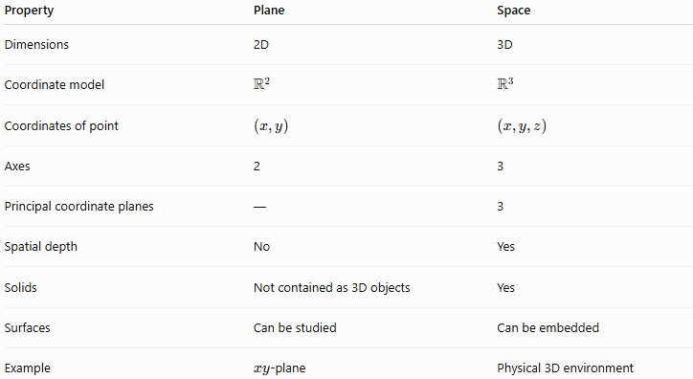
Property | Plane | Space
Dimensions | 2D | 3D
Coordinate model | $$R^{2}$$ | $$R^{3}$$
Coordinates of point | $$\left(x , y\right)$$ | $$\left(x , y , z\right)$$
Axes | 2 | 3
Principal coordinate planes | — | 3
Spatial depth | No | Yes
Solids | Not contained as 3D objects | Yes
Surfaces | Can be studied | Can be embedded
Example | $xy$-plane | Physical 3D environment

Key Points
# Source: AI Source: Provided by: [Data Path: Persons Table -> ID Column: 1, Name_En Column: Motasem Essam] -> From: [ChatGPT] on [7/20/2026]
- Space is the three-dimensional setting of spatial geometry.
- Standard Euclidean space is denoted by:
$$\boxed{R^{3}}$$
- A point in space requires three coordinates:
$$\boxed{\left(x , y , z\right)}$$
- The origin is:
$$\boxed{\left(0 , 0 , 0\right)}$$
- Space contains points, lines, planes, curves, surfaces, and solids.
- The three principal coordinate planes are $xy$, $xz$, and $yz$.
- Three-dimensional space is divided by these planes into eight octants.
- Solid Geometry studies three-dimensional objects within space.
- Surfaces such as spheres, cylinders, cones, and tori are geometric objects embedded in space.
- Spatial geometry extends many concepts from plane geometry into three dimensions.

Conclusion
# Source: AI Source: Provided by: [Data Path: Persons Table -> ID Column: 1, Name_En Column: Motasem Essam] -> From: [ChatGPT] on [7/20/2026]
Space is the three-dimensional geometric environment in which spatial objects and relationships exist. In Euclidean geometry, it is modeled by $R^{3}$, where every point is represented by three coordinates $\left(x , y , z\right)$.
It provides the foundation for Spatial Geometry and Solid Geometry, allowing the study of three-dimensional points, lines, planes, surfaces, solids, distances, angles, transformations, and spatial relationships.

